EXP NO : 3 : Implement Linear Regression

AIM : To implement Simple Linear Regression using Python and the Scikit-learn library to predict students' marks based on the number of hours studied, evaluate the model using Mean Squared Error (MSE) and R² Score, and visualize the actual data and regression line using Matplotlib.

ALGORITHM :
- Start the program.
- Import Pandas, Matplotlib, and the required functions from Scikit-learn.
- Load the dataset from the file data.csv.
- Select Hours_Studied as the input feature and Marks as the target variable.
- Split the dataset into training and testing sets in an 80:20 ratio using train_test_split().
- Create a Linear Regression model using LinearRegression().
- Train the model using model.fit() with the training data.
- Predict the marks for the testing data using model.predict().
- Evaluate the model by calculating the Mean Squared Error (MSE) and R² Score.
- Display the MSE, R² Score, and predicted marks.
- Plot the actual data using a scatter plot and the predicted values using a regression line.
- Add labels, a title, and a legend to the graph, and display it using plt.show().
- Stop the program.

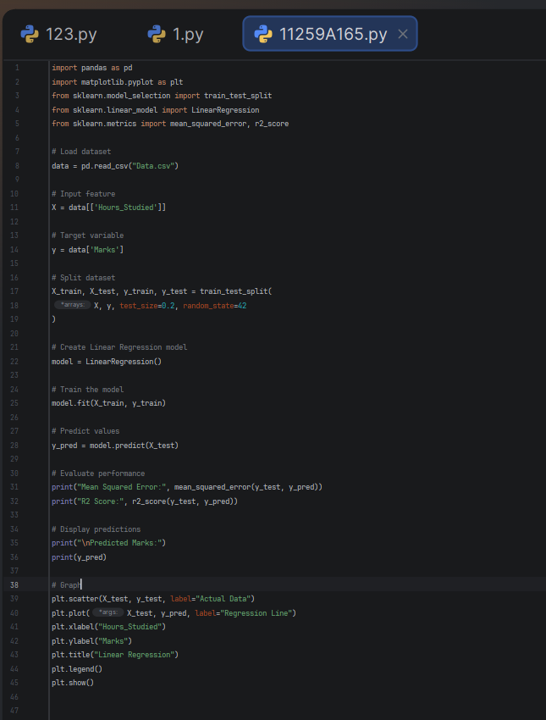
PROGRAM :

OUTPUT :

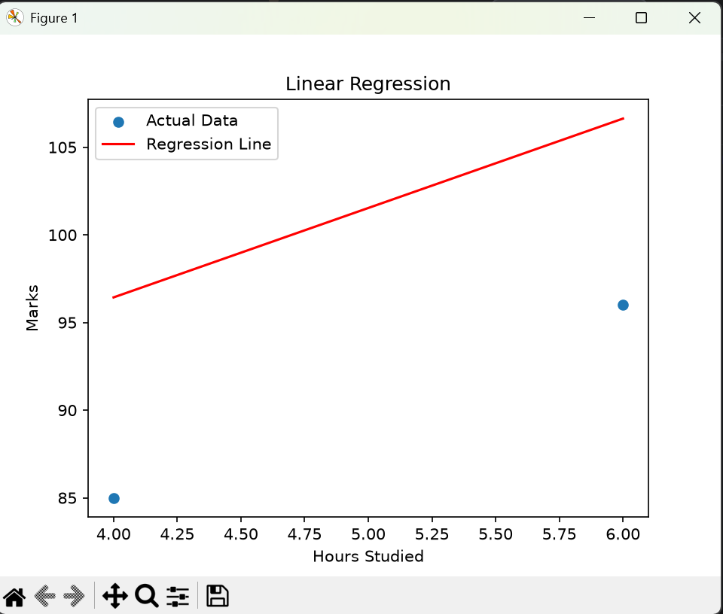

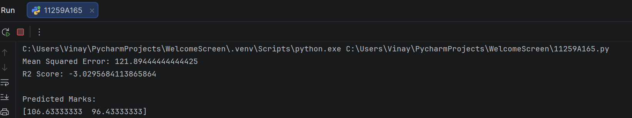
RESULT : Thus, the Simple Linear Regression model was implemented successfully to predict students' marks based on their study hours. The Mean Squared Error, R² Score, and predicted marks were displayed, and a graph showing the actual data points and the regression line was plotted.

